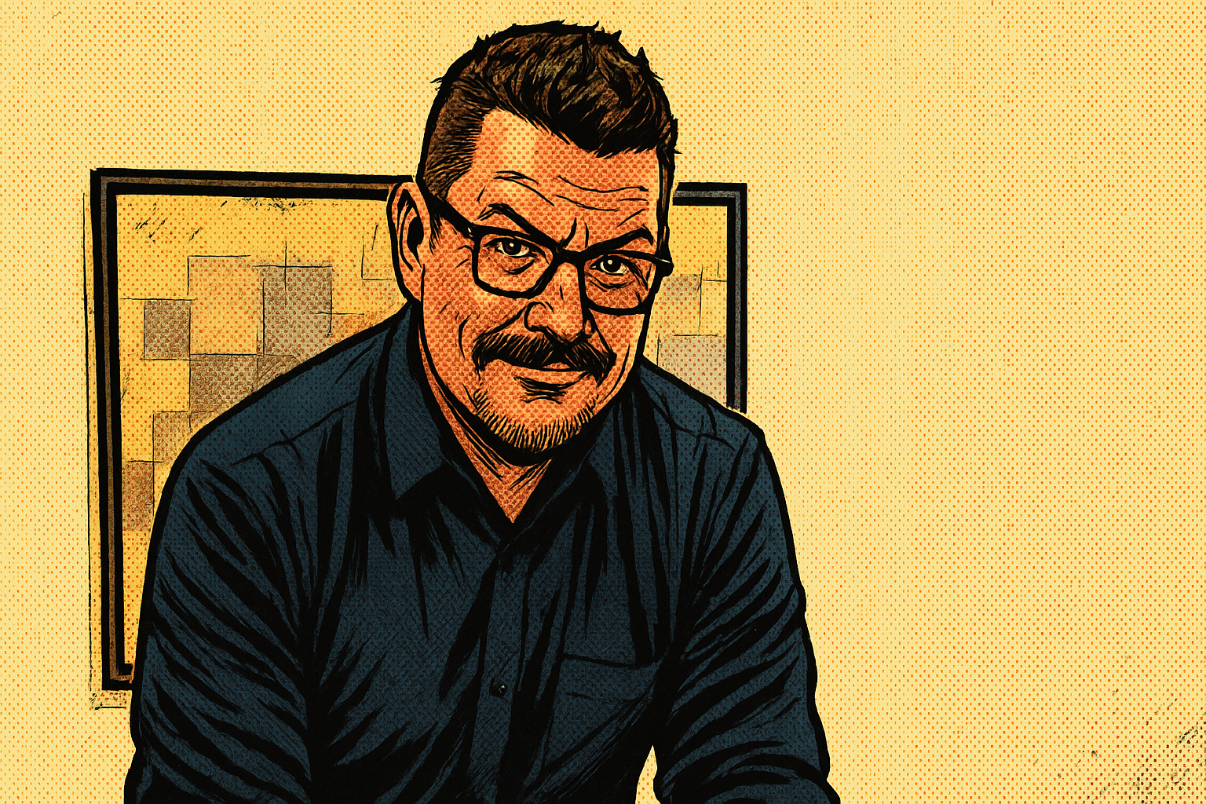 | NATE BALCOM  WEB DESIGNER/ SEO/ UX DESIGNER

CONTACT   Linkedin.com/in/nbalcom/  SKILLS  UX/UI Design, Wireframing, Prototyping, Responsive Web Design, HTML5 , CSS3, jQuery, JavaScript, PHP, WordPress, Elementor, Breakdance, Figma, Adobe XD, Sketch , Core Web Vitals, Google Lighthouse, SEO Audits , Google Tag Manager, GA4, Screaming Frog, SEMrush, Accessibility (WCAG 2.1, ARIA), Agile, Jira, Confluence | PROFESSIONAL SUMMARY  UX/UI Designer and SEO Specialist with over 10 years of experience crafting responsive, accessible, and search-optimized digital experiences. Proven ability to increase performance metrics and lead cross-functional teams to deliver user-centered solutions in Agile environments.  WORK EXPERIENCE  UX Optimization Specialist & SEO Web Designer  Momentum - Remote | Jan 2024 - Aug 2024  • Partnered with 10+ developers and content teams to deploy SEO and UX improvements that reduced page load time by 40% and improved engagement metrics by 25%.  • Achieved 100% WCAG 2.1 Level AA compliance across 25+ pages, passing internal audits and ensuring legal accessibility standards were met.  UX Designer / Developer  Cardinal Health - Remote | Jul 2022 - Aug 2023  • Created 12+ Adobe XD prototypes for routing and logistics apps, enabling product managers to reduce design iteration cycles by 35%.  • Delivered real-time Photoshop adjustments during 15+ stakeholder sessions, reducing design approval time by 50% and increasing client satisfaction.  UX Front-End Designer & SEO Specialist  SME - Remote | Jun 2021 - Jan 2022  • Collaborated with 6+ event directors to showcase emerging technologies, leading to a 30% increase in session registrations for tech-focused trade show events.  UX Designer - Electric Fleet Division  Ford Motor Company - Remote | Jan 2021 - Jun 2021  • Built and tested 10+ Sketch-based prototypes for electric fleet routing software, directly supporting successful MVP launches ahead of schedule.  Responsive Web Designer  Homedics - Remote | Apr 2020 - Jan 2021  • Designed and deployed 20+ responsive pages with marketing, boosting product page conversions by up to 45% during peak seasonal campaigns.  UX/UI Interaction Developer  Fiat Chrysler Automobiles - Auburn Hills, MI | May 2014 - Jan 2020  • Standardized usability testing protocols in partnership with HMI and electrical engineering teams, identifying 30+ UX issues before production.  • Selected to represent UX in 3 Google Design Sprints at Mountain View, contributing to next-gen infotainment concepts used across global markets.  Responsive Application Designer  United Healthcare - Remote | May 2013 - Jan 2014  • Ensured 100% accessibility compliance for 30+ web apps by integrating WCAG 2.1 standards and running monthly accessibility audits.  • Collaborated with certified accessibility teams to enhance cross-device UX, resolving 50+ compatibility and readability issues pre-launch.  EDUCATION    Western Michigan University - Kalamazoo, MI  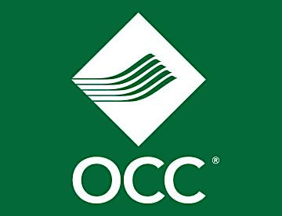  Bachelor of Arts in Fine Arts | Graduated March 1998  Oakland Community College - Auburn Hills & Orchard Lake, MI  Associate of Business | Graduated November 1994  CONFERENCES  • CES - Las Vegas, 2018  • Google I/O - Mountain View, 2017  • E3 Expo - Los Angeles, 2016  • Google Design Sprints - Mountain View, 2015–2016  KEY PROJECTS  Uconnect 5 Infotainment System  Fiat Chrysler Automobiles | May 2015 - Jan 2020  • Led UX efforts for Uconnect 5, contributing to a system now deployed in 10+ international vehicle lines, supporting 1M+ users worldwide.  • Developed over 50 wireframes and flows using Figma and Adobe XD for multi-platform applications, reducing design-to-dev turnaround by 40%.  • Executed 100+ in-vehicle test rides to identify and resolve UX issues, improving driver satisfaction scores by 20% based on post-test feedback.
   | Lake Orion, MI
   | +1(810) 510-9478
   | nathanbalcom@gmail.com
   | NateBal.com

